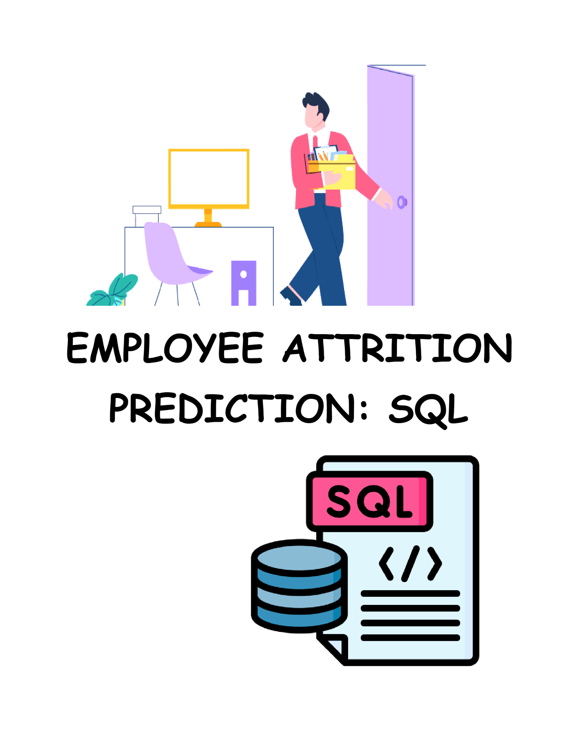

Creating table after connecting to the database

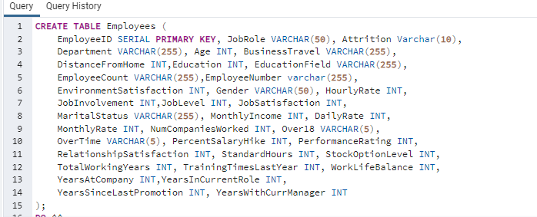

First view of data set

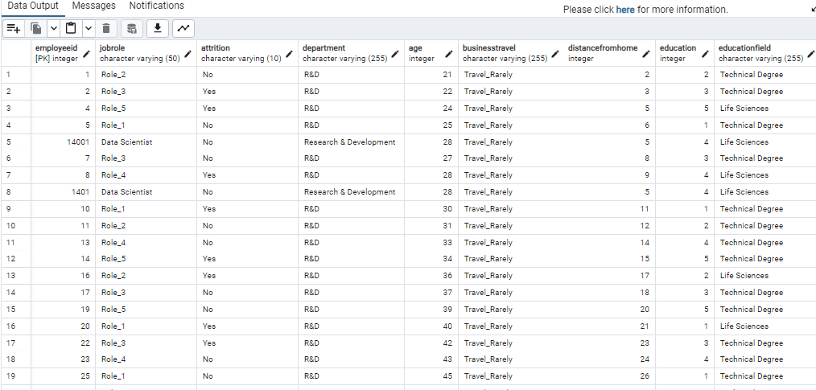

1. Departments with the Highest Attrition:

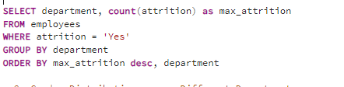

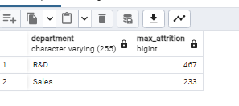

2. Gender Distribution across Different Departments:

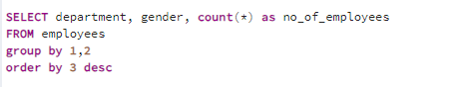

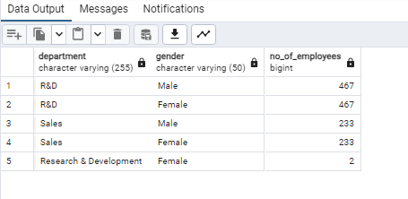

3. Job Satisfaction

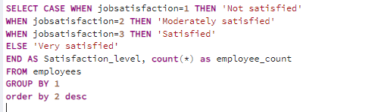

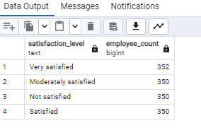

4. EMPLOYEE ATTRITION RATE BASED ON DIFFERENT FACTORS

4.a Attrition based on Age-group

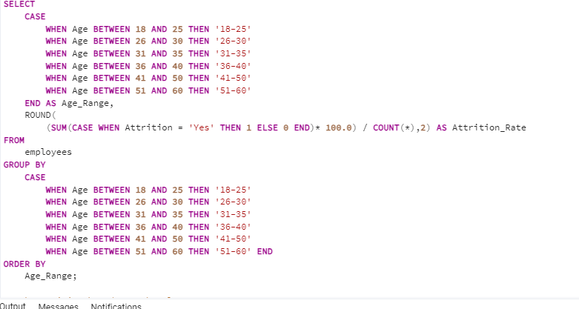

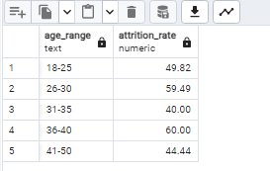

4.b Attrition based on Job Role

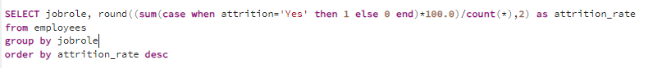

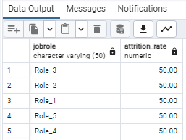

4.c Attrition rate based on Performance

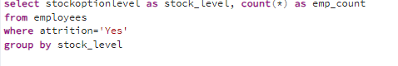

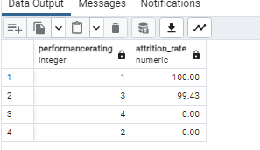

5. Correlation between Percent Salary Hike and Performance Rating:

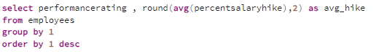

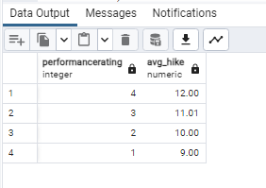

6. Career Progression Analysis: What is the average years at the company and total working years for different job roles?

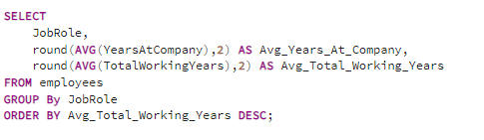

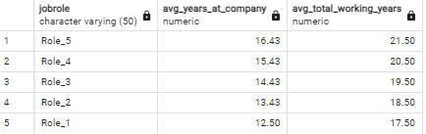

7. Gender Pay Gap Analysis: What is the average monthly income of male and female employees?

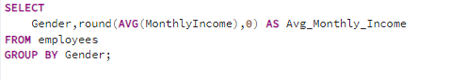

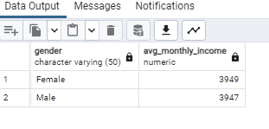

8. Distribution of performance ratings across different job roles and departments

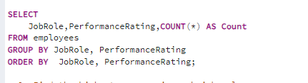

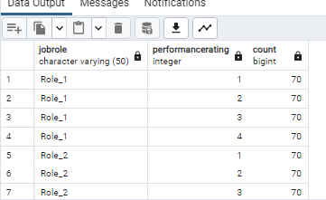

9. Find the highest earners in each job role

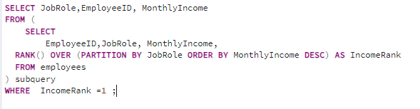

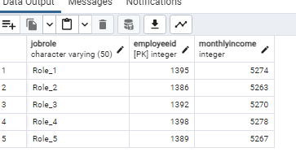

10. What is the Employee Retention Rate by Job Role

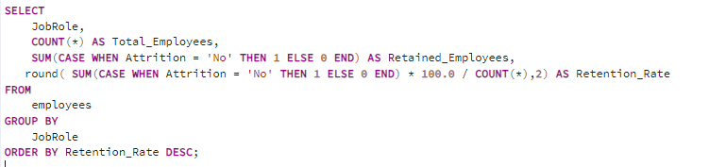

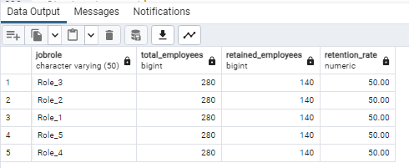

UPDATE Monthly income for Sales Department by 20%

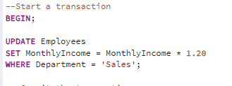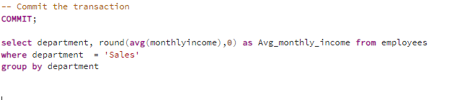

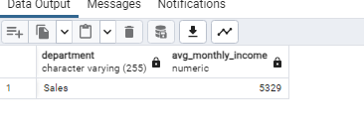

13. Delete Records of Employees Who Left the Company

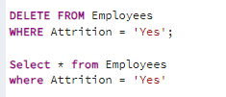

Suggest improvements in the database schema to reduce data redundancy and improve data integrity.

**Normalization:** Ensure the database follows normalization principles to minimize data redundancy and dependencies.

**Foreign Keys**: Use foreign keys to establish relationships, ensuring referential integrity and preventing orphaned records.

**Indexes:** Create indexes on frequently used columns to improve query

performance, but avoid excessive indexing.

**Default Values and Constraints:** Employ default values and constraints to enforce data integrity rules, reducing the risk of invalid data.

**Audit Trails:** Implement audit trails to track changes, providing a

historical record and enhancing accountability.

--**16. Explain how you can optimize the performance of SQL queries on this dataset.**

/*Here are few points for optimizing SQL queries on this dataset:

**Indexing**: Create indexes on columns frequently used in WHERE clauses or JOIN conditions to enhance query performance.

**Limit SELECT Columns:** Select only the necessary columns in your queries to reduce data transfer and improve efficiency.

**Optimize WHERE Clauses:** Ensure efficient WHERE clauses by avoiding functions on indexed columns and optimizing conditions.

**Use JOINs Efficiently:** Optimize JOIN operations by selecting the appropriate type and ensuring efficient join conditions.

**Update Statistics Regularly:** Keep table statistics up-to-date to assist the query planner in making informed execution plans.*/